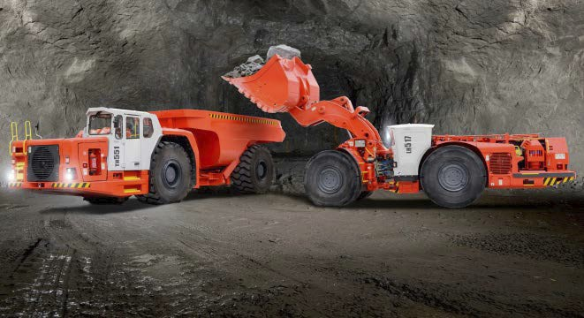
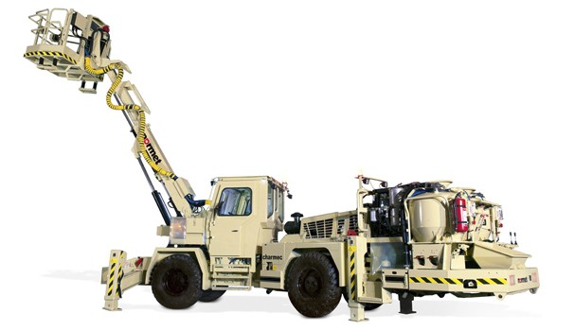
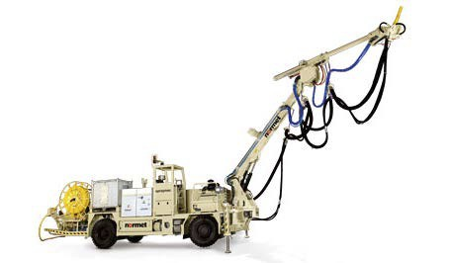
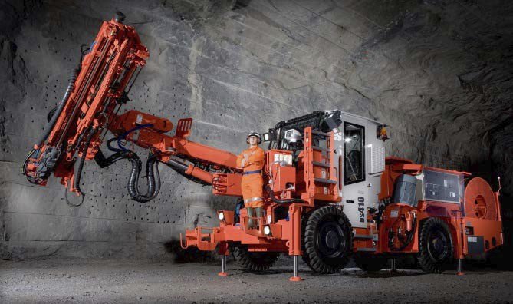
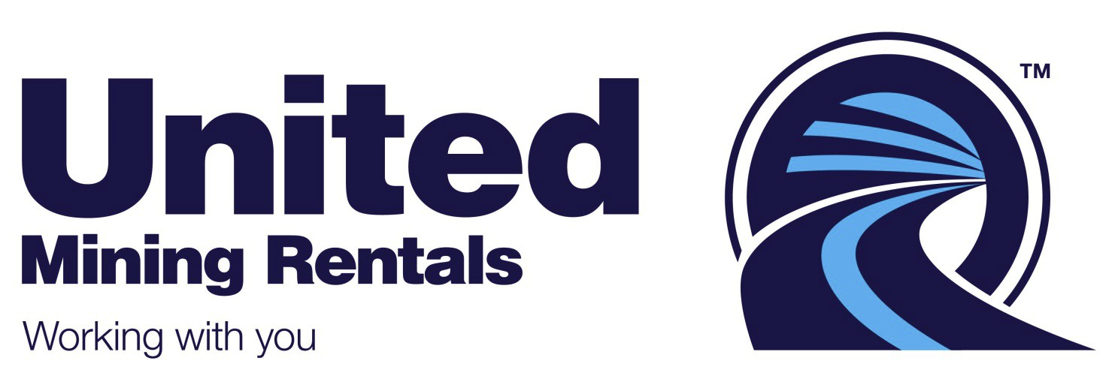

A new way forward…
Why buy when you can rent?
Striving to offer innovative pricing solutions and the highest quality products available to the mining and tunnelling communities, United Mining Rentals (UMR) is a venture driven by over 30 years of experience in the mining and tunnelling. Our focus at United Mining Rentals is to provide superior equipment and service tailored to the individual needs of our customers, anywhere in the world.

What we do:
United Mining Rentals specialises in offering a wide range of brand new equipment from two of the
most globally recognisable equipment brands; Sandvik and Normet for flexible rental deals. All of our
state of the art machines come with full factory warranty, and the option to purchase following a
minimum 12 month rent, with a pre-agreed % of rental payments contributing towards the final purchase price. Each rental deal is carefully customised with the optimal pricing and benefits for the customer in mind - with flexible options of 12, 24, or 36 month rental periods with no purchase commitments

www.unitedminingrentals.com info@unitedminingrentals.com

